THE ONTARIO
MATHEMATICS PROFICIENCY TEST (MPT)

TECHNICAL READINESS FORM
FOR INSTITUTION MANAGERS:
IN-PERSON TEST SESSIONS

Updated February 2021

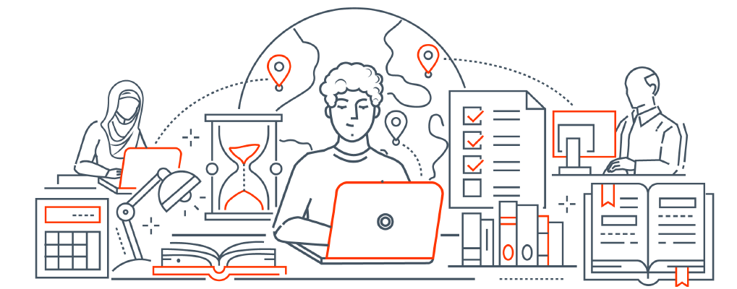
Contents
Useful Links 3
Glossary 3
Overview 6
Technical Readiness Form 7
Section 1: Contact Information 7
Section 2: Accessibility & Accommodation 7
Section 3: Bandwidth Requirements 8
Section 4: Security, Firewalls and Domain Safelisting 8
Section 5A: Test Locations Information (COMPUTER LAB METHOD) 9
Section 5B: Test Locations Information (BYOD METHOD) 11
Section 6: Validation Procedure for Invigilators 12
Section 7: Validation Procedure for Test Applicant Devices 12
Section 8: Test Centre Onboarding 12
Section 9: Signatures 13
Appendix 14
System Requirements for Invigilators 14
System Requirements for Test Applicants 14
Installing SEB on Windows 14
Installing SEB on macOS 16
Loading the SEB Configuration File (for Computer Labs) 17
Loading the SEB Configuration File (for BYOD) 18

Useful Links
MPT Platform | www.mathproficiencytest.ca
Safe Exam Browser | safeexambrowser.org/download_en.html

Glossary
The following chart includes terms used in this document and on the web portal.
Access Code | Confidential code set by Test Administrators and required by test applicants to sign up for a restricted test session.
Accommodation Coordinator | Person (typically from the accessibility office of the test centre) responsible for processing accommodation requests from test applicants.
AODA | Accessibility for Ontarians with Disabilities Act (2005).
Attempt Key | Unique code visible to a test applicant on completion of their test attempt.
BYOD | Bring Your Own Device
BYOD Method | An in-person method for administering test sessions at test centres with an Invigilator on-site. Test applicants complete the test on their own devices with the Safe Exam Browser (SEB) software.
Capacity | Number of test applicant spots available at a given test location.
College Application Number | Unique identifier provided by Ontario College of Teachers to prospective test applicants who wish to obtain a licence to teach in Ontario.
Computer Lab Method | An in-person method for administering test sessions in computer labs located at test centres with an Invigilator on-site. Test applicants are provided with computers on which they will complete the test with Safe Exam Browser (SEB) software.
EQAO | Education Quality and Accountability Office, responsible for planning, constructing, and scoring of the MPT. Also responsible for determining the procedure for all aspects of test delivery (within the bounds of legislation).
Hidden Test Session | Restricted Test Session that is hidden from test applicants and only accessible via an invitation link.
Institution Manager | Individual at the test centre assigned to create an Accommodation Coordinator account and Invigilator accounts, manage accounts, and create test sessions.
Invigilator | Assigned individual monitoring the test session.
Invitation Code | Code that is included in the invitation email sent by EQAO to the contact at the test centre to create a Test Administrator account.
In-Person Methods | Methods for administering a test session at a test centre with an Invigilator on-site. Includes Computer Lab Method and BYOD Method.
MPT | Ontario Mathematics Proficiency Test, required for Ontario Teacher Certification.
OCT | Ontario College of Teachers. Certification body that issues teaching certificates.
Primary Technical Contact | Assigned individual at the test centre responsible for validating devices used for the MPT.
Remotely Administered Method | A method for administering a test session at a distance that allows for remote proctoring by an Invigilator using video conferencing software. Video Conferencing is the only Remotely Administered Method available.
Restricted Test Session | Test session that is restricted and viewable only by test applicants who require an accommodation. Access to these test sessions is possible only through an invitation link or access code created by the Accommodation Coordinator.
SEB | Safe Exam Browser. Lock-down browser used for the MPT.
Technical Readiness Team | Team that provides training and technical support to Test Administrators and test applicants throughout the administration of the MPT.
Test Administrators | Contacts at test centres. Includes the roles of Institution Manager, Accommodation Coordinator and Invigilator.
Test Applicants | Individuals taking the Mathematics Proficiency Test (MPT).
Test Centre | A post-secondary institution that provides a program of professional education, accredited by the Ontario College of Teachers, or an approved test centre that will administer the test.
Test Location | Location where the test session is held for in-person administration.
Test Session | Scheduled 3-hour time slot in which the MPT is administered. Test Administrators can extend the time slot to 4 hours, if required.
Test Window | A time period (pre-determined by EQAO and its partners) during which test sessions can take place.
WCAG | Web Content Accessibility Guidelines

Overview
This Technical Readiness Form is designed to guide the Primary Technical Contact at the test centre in validating the infrastructure that is provisioned to be used to administer the test at a specific set of locations and time slots. This infrastructure includes (but is not limited to) the computers/devices used by the Invigilator to control access to the test, the computers/devices used by test applicants to attempt the test (see table below for Bring Your Own Device considerations), the network made available to access the test, and the rooms in which the test session takes place.

Sections to be Completed in this Form | Computer Lab Method | BYOD Method
Section 1: Contact Information | ✅ | ✅
Section 2: Accessibility & Accommodation | ✅ | ⛔
Section 3: Bandwidth Requirements | ✅ | ✅
Section 4: Security, Firewalls and Domain Safelisting | ✅ | ✅
Section 5A: Test Locations Information (Computer Lab Method) | ✅ | ⛔
Section 5B: Test Locations Information (BYOD Method) | ⛔ | ✅
Section 6: Validation Procedure for Invigilators | ✅ | ✅
Section 7: Validation Procedure for Test Applicant Devices | ✅ | ⛔
Section 8: Test Centre Onboarding | ✅ | ✅
Section 9: Signatures | ✅ | ✅

Technical Readiness Form
The Technical Readiness Form is available to be completed below. In the case of test sessions that are conducted in a controlled computer lab environment, this form should be completed by the Institution Manager and the Primary Technical Contact who has access to authenticate and install software on the devices. In the case of a BYOD delivery, it is possible for the Institution Manager to complete this form on their own.
You may extend the rows in the form below using Microsoft Word, as required, to ensure that all relevant information is included for each test location that will be used. Once the form has been completed, it must be uploaded by the Institution Manager through the test session creation wizard on the MPT platform.

S1 | Section 1: Contact Information
S1.1 | Test Centre
S1.1.1 | Name of Test Centre
S1.1.2 | Name of the Institution Manager  This is the person who downloaded this form from the MPT platform.
S1.2 | Primary Technical Contact
S1.2.1 | Full Name
S1.2.2 | Role/Title
S1.2.3 | Department
S1.2.4 | Physical Address
S1.2.5 | Email Address
S1.2.6 | Telephone Number
S2 | Section 2: Accessibility & Accommodation
S2.1 | Please indicate which assistive technologies your test centre has access to by marking the Yes or No column with a checkmark.  This section will need to be discussed with the Accommodation Coordinator. If additional software is needed, please contact the support team. | YES  If yes, indicate the number of licences held by your test centre | NO
S2.1.1 | Dragon NaturallySpeaking
S2.1.2 | Kurzweil 3000
S2.1.3 | NVDA Screen Reader
S2.1.4 | Read&Write (R&W)
S2.1.5 | Built-in text-to-speech
S2.2 | Please read through the following questions and indicate the appropriate column with a checkmark or provide the information requested, if applicable. | YES | NO
S2.2.1 | Has the Accommodation Coordinator indicated any need for additional software (apart from those listed in S2.1) to be installed in any of the respective test locations?
S2.2.2 | If the answer to the above question is yes, please list the additional software that is required so that you can be provided a new SEB configuration file.
S3 | Section 3: Bandwidth Requirements
S3.1 | How are the computers connected to the Internet?  Wired or Wi-Fi?
S3.2 | What is the bandwidth available to each device that will be used in the test?  The test requires a connection that does not go below 80 kbps per device, and for optimal functioning an average of 2 Mbps or greater is recommended.
S4 | Section 4: Security, Firewalls and Domain Safelisting
 | Please read through the following questions and indicate the appropriate column with a checkmark. | YES | NO
S4.1 | Does your test centre have a firewall that protects data in computer labs and other devices on the network?
S4.2 | Does your test centre have a firewall that protects the network?
S4.3 | If you have a firewall, have you added the following MPT domains to the safelist?  mathproficiencytest.ca  api.mathproficiencytest.ca  api2.mathproficiencytest.ca  api3.mathproficiencytest.ca  api4.mathproficiencytest.ca
S5A | Section 5A: Test Locations Information (COMPUTER LAB METHOD)  Skip this section if you have opted for a BYOD test delivery.
S5A.1 | Test Location #1
S5A.1.1 | Location Room Number, Building, and Address
S5A.1.2 | Number of Computer Stations Available (Capacity)
S5A.1.3 | Date(s) and Time(s) of Room Availability
S5A.1.4 | Date(s) and Time(s) of Test Session(s)
S5A.1.5 | Accessibility Software (and number of installed licenses)
 | Please read through the following questions and indicate the appropriate column with a checkmark. | YES | NO
S5A.1.6 | Has the Safe Exam Browser (SEB) software been installed on all of the computer stations (that are indicated as "available" above)?  See installation instructions in Appendix.
S5A.1.7 | Has a process been established to ensure that the SEB software will remain installed (or be re-installed) immediately prior to the time slots in which the test will be administered?
S5A.1.8 | Has a process been established to load and remove the SEB configuration files immediately prior to and following the test?
S5A.1.9 | Do the computers have access to a stable connection that meets the minimum standard defined in the "Bandwidth Requirements" section of this form?
S5A.1.10 | Are all screen displays free of flickering, and do they all show full colour and render text properly at various zoom levels?
S5A.1.11 | Are all keyboard keys functioning correctly and do they allow both English and French keyboard configurations (with clearly labelled keys)?
S5A.1.12 | Do all mice and touchpads provide full degrees of motion (and a functional scroll wheel where applicable)?
S5A.1.13 | Are the system clocks on the devices synchronized to the standard clock?
S5A.1.14 | Is the room reservation indicated in a scheduling system that is managed by the test centre?
S5A.1.15 | Will Invigilators have access to the room at least 20 minutes prior to the session in order to verify that everything is in order for the test session?
S5A.2 | Test Location #2
S5A.2.1 | Location Room Number, Building, and Address
S5A.2.2 | Number of Computer Stations Available (Capacity)
S5A.2.3 | Date(s) and Time(s) of Room Availability
S5A.2.4 | Date(s) and Time(s) of Test Session(s)
S5A.2.5 | Accessibility Software (and number of installed licenses)
 | Please read through the following questions and indicate the appropriate column with a checkmark. | YES | NO
S5A.2.6 | Has the Safe Exam Browser software been installed on all of the computer stations (that are indicated as "available" above)?  See installation instructions in Appendix.
S5A.2.7 | Has a process been established to ensure that the software will remain installed (or be re-installed) immediately prior to the time slots in which the test will be administered?
S5A.2.8 | Has a process been established to load and remove the SEB configuration files immediately prior to and following the test?
S5A.2.9 | Do the computers have access to a stable connection that meets the minimum standard defined in the "Bandwidth Requirements" section of this form?
S5A.2.10 | Are all screen displays free of flickering, and do they all show full colour and render text properly at various zoom levels?
S5A.2.11 | Are all keyboard keys functioning correctly and do they allow both English and French keyboard configurations (with clearly labelled keys)?
S5A.2.12 | Do all mice and touchpads provide full degrees of motion (and a functional scroll wheel where applicable)?
S5A.2.13 | Are the system clocks on the devices synchronized to the standard clock?
S5A.2.14 | Is the room reservation indicated in a scheduling system that is managed by the test centre?
S5A.2.15 | Will Invigilators have access to the room at least 20 minutes prior to the session in order to verify that everything is in order for the test session?
 | You may extend the rows in this table if you need to enter additional locations.

S5B | Section 5B: Test Locations Information (BYOD METHOD)  Skip this section if you have opted for a Computer Lab test delivery.
S5B.1 | Location #1
S5B1.1 | Location Room Number, Building, and Address
S5B1.2 | Number of Seats and Desks Available (Capacity)
S5B1.3 | Date(s) and Time(s) of Room Availability
S5B1.4 | Date(s) and Time(s) of Test Session(s)
 | Please read through the following questions and indicate the appropriate column with a checkmark. | YES | NO
S5B1.5 | Do test applicants have access to a strong and stable Wi-Fi signal from within the room (see "Bandwidth Requirements" section of this form)?
S5B1.6 | Does the room have a Wi-Fi router that prevents connections from being degraded as a result of heavy use unrelated to the test session?
S5B1.7 | Does your test centre have appropriate cyber security measures in place to mitigate cyber threats to the test centre?
S5B1.8 | Is the room reservation indicated in a scheduling system that is managed by the test centre?
S5B.2 | Location #2
S5B.2.1 | Location Room Number, Building, and Address
S5B.2.2 | Number of Seats and Desks Available (Capacity)
S5B.2.3 | Date(s) and Time(s) of Room Availability
S5B.2.4 | Date(s) and Time(s) of Test Session(s)
 | Please read through the following questions and indicate the appropriate column with a checkmark. | YES | NO
S5B.2.5 | Do test applicants have access to a strong and stable Wi-Fi signal from within the room (see "Bandwidth Requirements" section of this form)?
S5B.2.6 | Does the room have a Wi-Fi router that prevents connections from being degraded as a result of heavy use unrelated to the test session?
S5B.2.7 | Does your test centre have appropriate cyber security measures in place to mitigate cyber threats to the test centre?
S5B.2.8 | Is the room reservation indicated in a scheduling system that is managed by the test centre?
 | You may extend the rows in this table if you need to enter additional locations.

S6 | Section 6: Validation Procedure for Invigilators
 | Please read through the following questions and indicate the appropriate column with a checkmark. | YES | NO
S6.1 | Has an Invigilator signed into the MPT website using the device that will be used for the invigilation?  See System Requirements for Invigilators in Appendix.
S6.2 | Do the Invigilators have a contact whom they can call in the event of technical difficulty prior to or during the test session?
S7 | Section 7: Validation Procedure for Test Applicant Devices  Skip this section if you have opted for a BYOD test delivery (in which case the test applicants are responsible for testing their own devices).
 | Please read through the following questions and indicate the appropriate column with a checkmark. | YES | NO
S7.1 | Have you completed the practice test available on the MPT website using a representative sample of devices in the room?
S7.2 | Did you encounter any issues when testing the devices?
S8 | Section 8: Test Centre Onboarding
 | Please read through the following questions and indicate the appropriate column with a checkmark. | YES | NO
S8.1 | Was there any question on this form that gave you concern as to the ability to administer the test session using your available infrastructure?
S8.2 | Is this the first time that either you or your test centre are administering the MPT?
S8.3 | If the answer to either of the above questions is "Yes", you will need to schedule a call with the MPT Technical Readiness Team prior to signing off on this Technical Readiness Form. Please email support@mathproficiencytest.zendesk.com.
S9 | Section 9: Signatures
S9.1 | Institution Manager
S9.1.1 | Name
S9.1.2 | Date
S9.1.3 | Signature
S9.2 | Primary Technical Contact
S9.2.1 | Name
S9.2.2 | Date
S9.2.3 | Signature

Appendix

System Requirements for Invigilators
The technology used to run the MPT follows modern security and performance standards; however, it is important to ensure that the computers/devices being used for the MPT are technically suitable for running the test.
The screens that the Invigilators use on test day should be at least 768 x 1024 pixels.
Please consult the chart below to identify which browsers and operating systems are compatible with the MPT website:
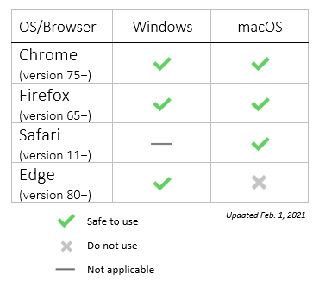

System Requirements for Test Applicants
The test can only be accessed via the Safe Exam Browser (SEB), using a valid configuration file provided from the MPT website. The SEB program is a specialized web browser that restricts test applicants’ access to tools and resources while they are taking the test. The SEB configuration file regulates access to system functions, other applications, and other settings, while also pointing the SEB program to the test and performing a special "handshake" to validate security.

Installing SEB on Windows
1. Download the Safe Exam Browser Installer from the SEB website at https://safeexambrowser.org/download_en.html#WindowsLegacy.

Click the download link for the Safe Exam Browser 2.4.1 for Windows.

Please note: The assessment is compatible up to version 2.4.1 of the SEB (Legacy version) for Windows.



2. Once the download is complete, run the “SafeExamBrowserInstaller.exe” file to initiate the installation.
You will be asked to allow the installation to make changes on your device. You must accept this to proceed.

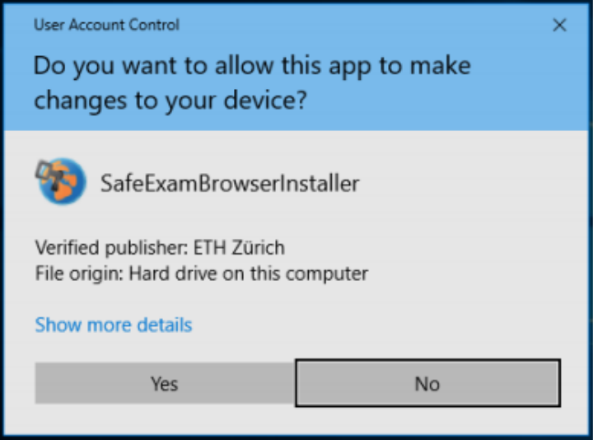

3. You will be presented a Wizard. Click the "Next" button to proceed. Select “I accept the terms in the license agreement”, “Install”, and “Finish”.
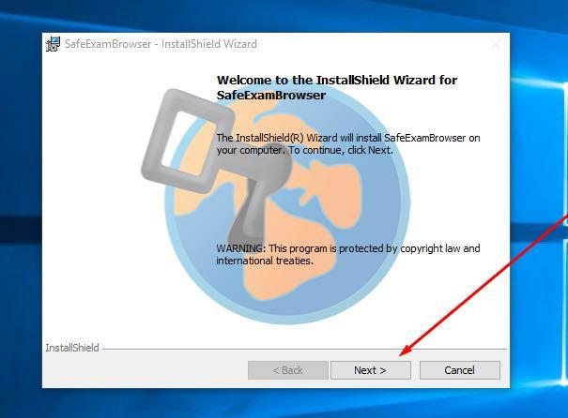

4. Click “Start” and find “Safe Exam Browser” to run the program.



5. You will likely see the picture below with the alert: “You have installed Safe Exam Browser (SEB), but it isn’t configured yet.” This indicates that the installation of the program is complete.
For instructions on how to access the test, please see the section "Loading the SEB Configuration File (for Computer Labs)".

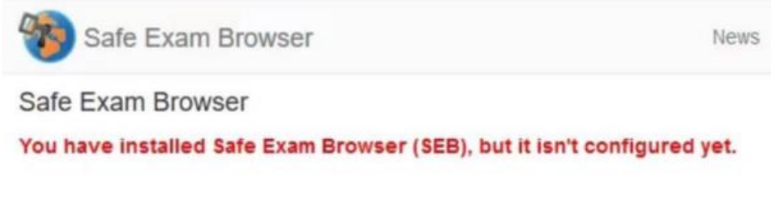

Installing SEB on macOS
1. Navigate to the "About This Mac" menu in your system menu bar to see if the device is compatible with the SEB.

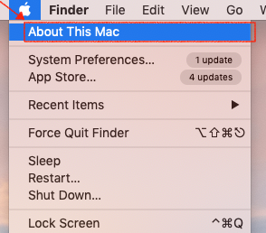

2. You will see a window containing the version of your operating system. It must be higher than Mac OS X 10.8 to run the Safe Exam Browser for the exam you are taking. In most cases, it is possible to upgrade the operating system at no cost, but it can take more than an hour.

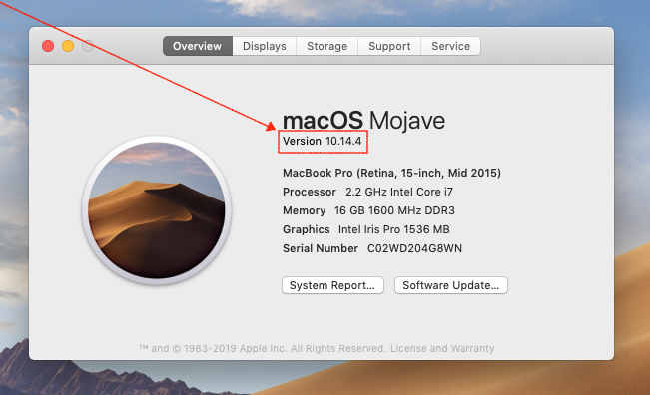

3. Download the Safe Exam Browser Installer from the SEB website at https://safeexambrowser.org/download_en.html#MacOSX.

Click the download link for the Safe Exam Browser 2.2.2 for macOS.

Please note: The assessment is compatible up to version 2.2.2 of the SEB.



4. Double click on the .DMG file.

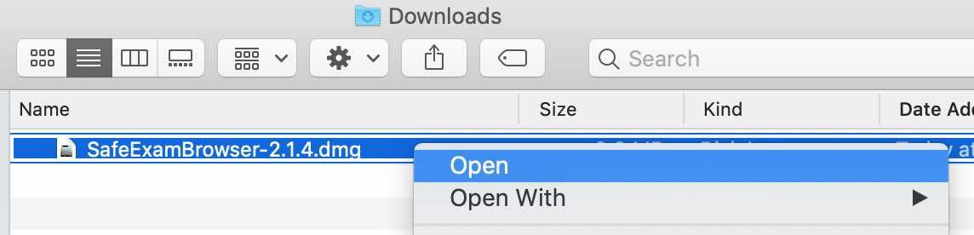

5. Drag the Safe Exam Browser icon and drop it in the Applications folder icon to the right. You will be asked for an administrator username and password for the computer.

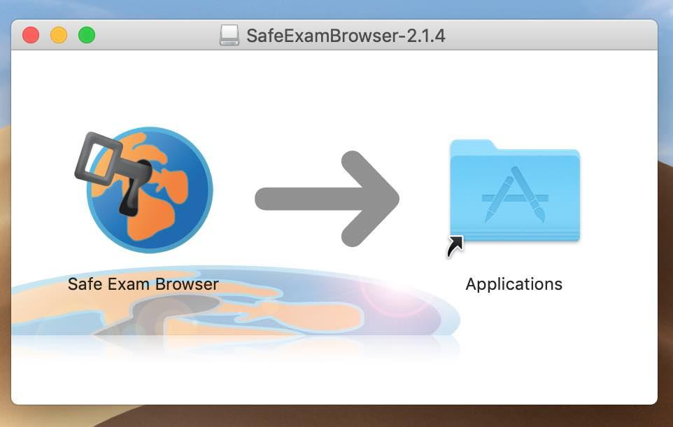

6. You can verify the installation by opening Safe Exam Browser (via Spotlight). The Safe Exam Browser should open at full screen with a message that it needs settings or a link to continue. This indicates that the installation of the program is complete.
For instructions on how to access the test, please see the section "Loading the SEB Configuration File (for Computer Labs)".

Loading the SEB Configuration File (for Computer Labs)
In order to access the test, the MPT website needs to be opened through the Safe Exam Browser using a test applicant SEB configuration file. This file opens to a login screen which then opens directly to the test.
When the computer lab is being set up for the MPT, all of the computers should be opened to SEB prior to test applicants entering the room. Please note that the software should not be opened directly, but by double-clicking on the configuration file.

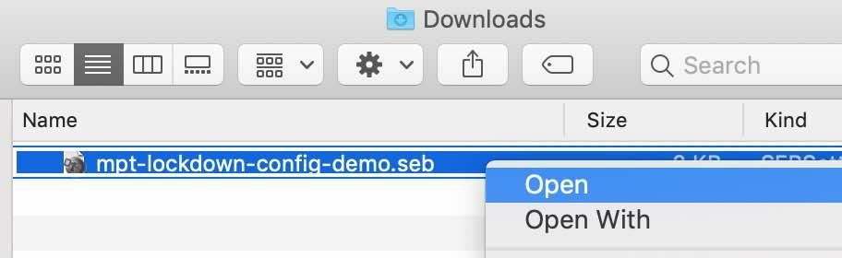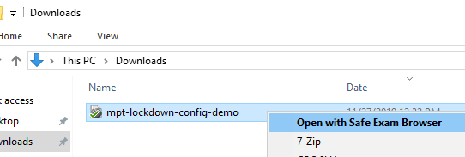

Please Note: The configuration file must be completely removed from each computer before the last test administrator leaves the test room.
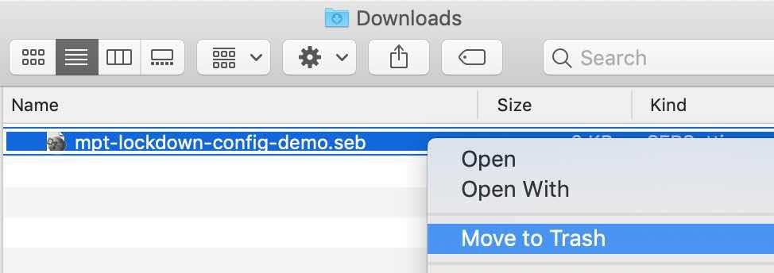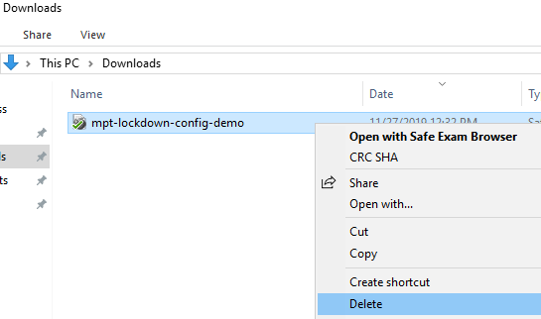
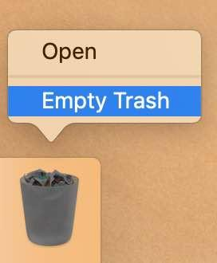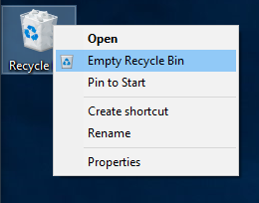

Loading the SEB Configuration File (for BYOD)
In order to access the test, the MPT website needs to be opened through the Safe Exam Browser using a test applicant SEB configuration file. This file opens to a login screen which then opens directly to the test.
In a BYOD test administration, test applicants download their version of the SEB configuration file from within the MPT website. The SEB file should never be provided directly to test applicants by the Test Administrator. The configuration file that is provided directly to test applicants has reduced security, which is accommodated for during the test session by preventing their start of the test until their identity and presence have been verified.
Please Note: Chromebooks and iPads are not supported at this time.

